Comparative Analysis of Linear, Nonlinear, and MLP Models for Blood Cell Anomaly Classification
Robert Vazquez Rosales
CSCE 580: Applied Machine Learning with Python
University of South Carolina
Columbia, USA
ryv@email.sc.edu
Jerry Qiu
CSCE 580: Applied Machine Learning with Python
University of South Carolina
Columbia, USA
JJQIU@email.sc.edu
Homayoun Valafar
CSCE 580: Applied Machine Learning with Python
Univeristy of South Carolina
Columbia, USA
homayoun@cse.sc.edu
-
-
-
-

Abstract—This study presents a comparative analysis of machine learning models for multi-class classification of blood cell anomalies using structured tabular data. The objective is to evaluate the effectiveness of linear, nonlinear, and MLP approaches in capturing complex relationships
Three models were implemented: Logistic regression as a baseline linear model, Random Forest as a nonlinear method, and a Multi-Layer Perceptron as a ANN. The dataset was preprocessed using one-hot encoding for categorical variables and feature standardization for neutral network training. Stratified train-validation-test split was employed to preserve class distributions.
Model performance was evaluated using accuracy, F1 score, recall, and confusion matrices. Logistic Regression achieved an accuracy of 97.51%, Random Forest achieved 97.73%, and the MLP achieved 96.94%. The results indicate that the dataset is highly separable, allowing simple linear models to perform extremely well.
This study highlights that increased model complexity does not always yield better performance and emphasizes the importance of selecting models appropriate to the structure. There is also a light analysis of separate hyperparameters and the insights they provide on the dataset.
Keywords—Machine learning, Multi-class Classification, Blood Cell Analysis, Logistic Regression, Random Forest, Neural Networks (MLP)

Introduction
Machine learning has become an essential tool for solving classification problems across various domains including biomedical analysis, where accurate classification has important real-world implications. The performance of machine learning models depends on underlying abilities to capture patterns in data.
This paper focuses on classification of blood cell anomalies using a structured dataset containing features that describe properties of individual cells. The task is formulated as a multi-class classification problem, where each sample must be assigned a specific cell type or anomaly category.
The primary objective of this study is to compare the performance of different machine learning models of varying complexity. Specifically, a linear model (linear regression), a nonlinear model (Random Forest), and a neural network model (Multi-layer Perceptron). There is also an analysis on the dataset via hyperparameter tuning of each model, and how each hyperparameter shows more insight into the nature of the dataset.
By comparing these models we hope to see how complexity influences classification performance and to highlight the importance of selecting appropriate methods

Background
Machine learning models for classification can be broadly categorized into linear models, nonlinear models, and neural networks.
Logistic Regression is a linear model that assumes a linear relationship between input features and target classifications. It is widely used for its simplicity and interpretability.
Random Forest is a nonlinear model that builds multiple decision trees and aggregates their predictions. It is effective at capturing feature interaction and nonlinear patterns.
Artificial Neural Networks such as Multi-Layer Perceptrons (MLPs), consist of multiple layers of interconnected neurons with nonlinear activation functions. These models can learn complex representations and are widely used for high-dimensional data.
Comparing these approaches allows for a better understanding of how model complexity might affect performance.

DATA
The dataset used in this study is the Blood Cell Anomaly Detection dataset. It consists of structured tabular data describing properties of individual blood cells. The task is a multi-class classification problem in which each sample is labeled according to a specified cell type or anomaly category.
The dataset includes both numerical and categorical features representing characteristics of blood cells. These features provide meaningful biological information that can be used to classify the separate classes.
Categorical features were transformed using one-hot encoding to ensure they were compatible with machine learning models. Numerical features were standardized for neural network training to improve performance and convergence.
A stratified train-validation-test split was applied, dividing into 70% training, 15% validation, and 15% testing subsets. This approach preserves class distribution across the splits.

Method
Logistic Regression was used as a baseline linear model. Hyperparameter tuning was performed on the regularization parameter to optimize performance while maintaining model simplicity. Three total models were trained with differing regularization. Model 1 had a regularization value of 1.0, Model 2 had a regularization value of 2.0, and Model 3 had a regularization value of 0.5. Out of the three models, Model 1 performed the best and was used as the prominent model
Random Forest was used as the nonlinear mode. Hyperparameter tuning was performed on the max depth of trees and ran at a constant tree count. Three total models were trained with differing max depth of trees. Model 1 had a max depth of 10, Model 2 did not have a max depth, and Model 3 had a max depth of 20. Out of the three models, Model 3 performed the best and was used as the prominent model.
The neural network was implemented as a Multi-Layer Perceptron (MLP) with fully connected layers and nonlinear activation functions (RELU). Input features were standardized, the model was trained using ADAM optimizer and cross-entropy loss across multiple epochs. The total structure of tee model was an initial layer of input dimensions to 64, then a RELU activation function, a hidden layer mapping 64 neurons to 32 neurons, another RELU activation function, and finally mapping the final 32 neurons to a final output layer of the number of classes. Three total models were trained with differing levels of dropout. Model 1 had a dropout value of 0.1 before the first hidden layer, Model 2 had no dropout value, and Model 3 had a dropout value of 0.3 placed in the same location as Model 1. Out of the three models, Model 3 performed the best and was used as the prominent model
All models were evaluated using accuracy, F1 score, recall, and confusion matrices.

Results
The results show that all models perform at a high level on this classification task.
Logistic Regression achieved an accuracy of 97.51%. This shows that the patterns found in the data have strong linear relationships and nonlinear relationships do not necessarily need to be explored in order to get high accuracies. Alongside this, Model 2 showed an accuracy of 97.28% and Model 3 also showed an accuracy of 97.28%.
Random Forest achieved the highest performance with an accuracy of 97.73%, showing a slight improvement due to its ability to capture nonlinear relationships. Alongside this, Model 1 had an accuracy of 97.62% and Model 2 also had an accuracy of 97.62% as well.
The Multi-Layer Perceptron achieved an accuracy of 96.64%, which is comparable to the other models but a little lower. Despite its complexity, the MLP did not provide any significant advantage to this dataset. Alongside this, Model 1 showed an accuracy of 96.49% and Model 2 showed an accuracy of 96.26%.
 | Logistic Regression | Random Forest | Multi-Layer Perceptron
Accuracy | 0.9751 | 0.9773 | 0.9694
F1 Score | 0.9746 | 0.9764 | 0.9694
Recall | 0.9751 | 0.9773 | 0.9694

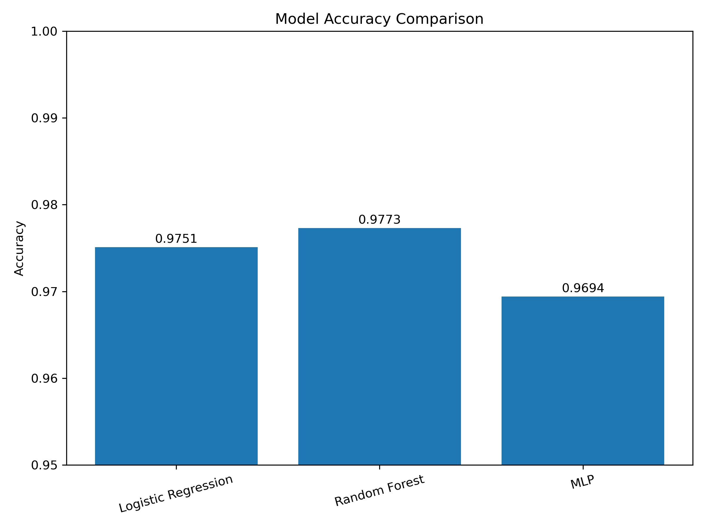

Fig. 1. Model accuracy comparison across Logistic Regression (97.51%), Random Forest (97.73%), and MLP (96.94%). Random Forest achieves the highest accuracy, though all models perform within a narrow range, indicating strong feature separability in the dataset.
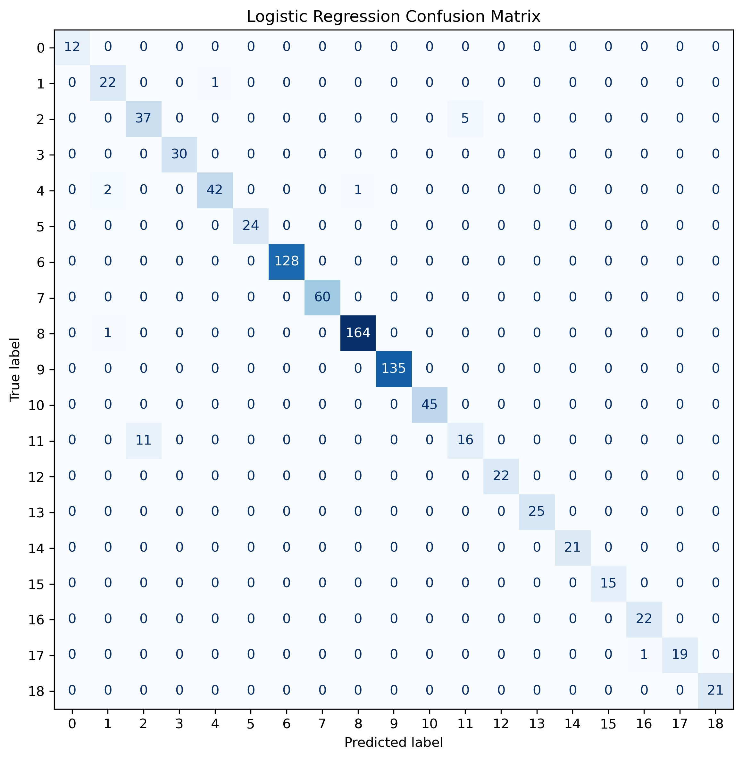

Fig. 2. Confusion matrix for Logistic Regression. The model classifies correctly across nearly all 19 classes. Most misclassifications occur in class 11, where 11 samples are incorrectly predicted as class 2, suggesting visual or feature-level similarity between those anomaly types.
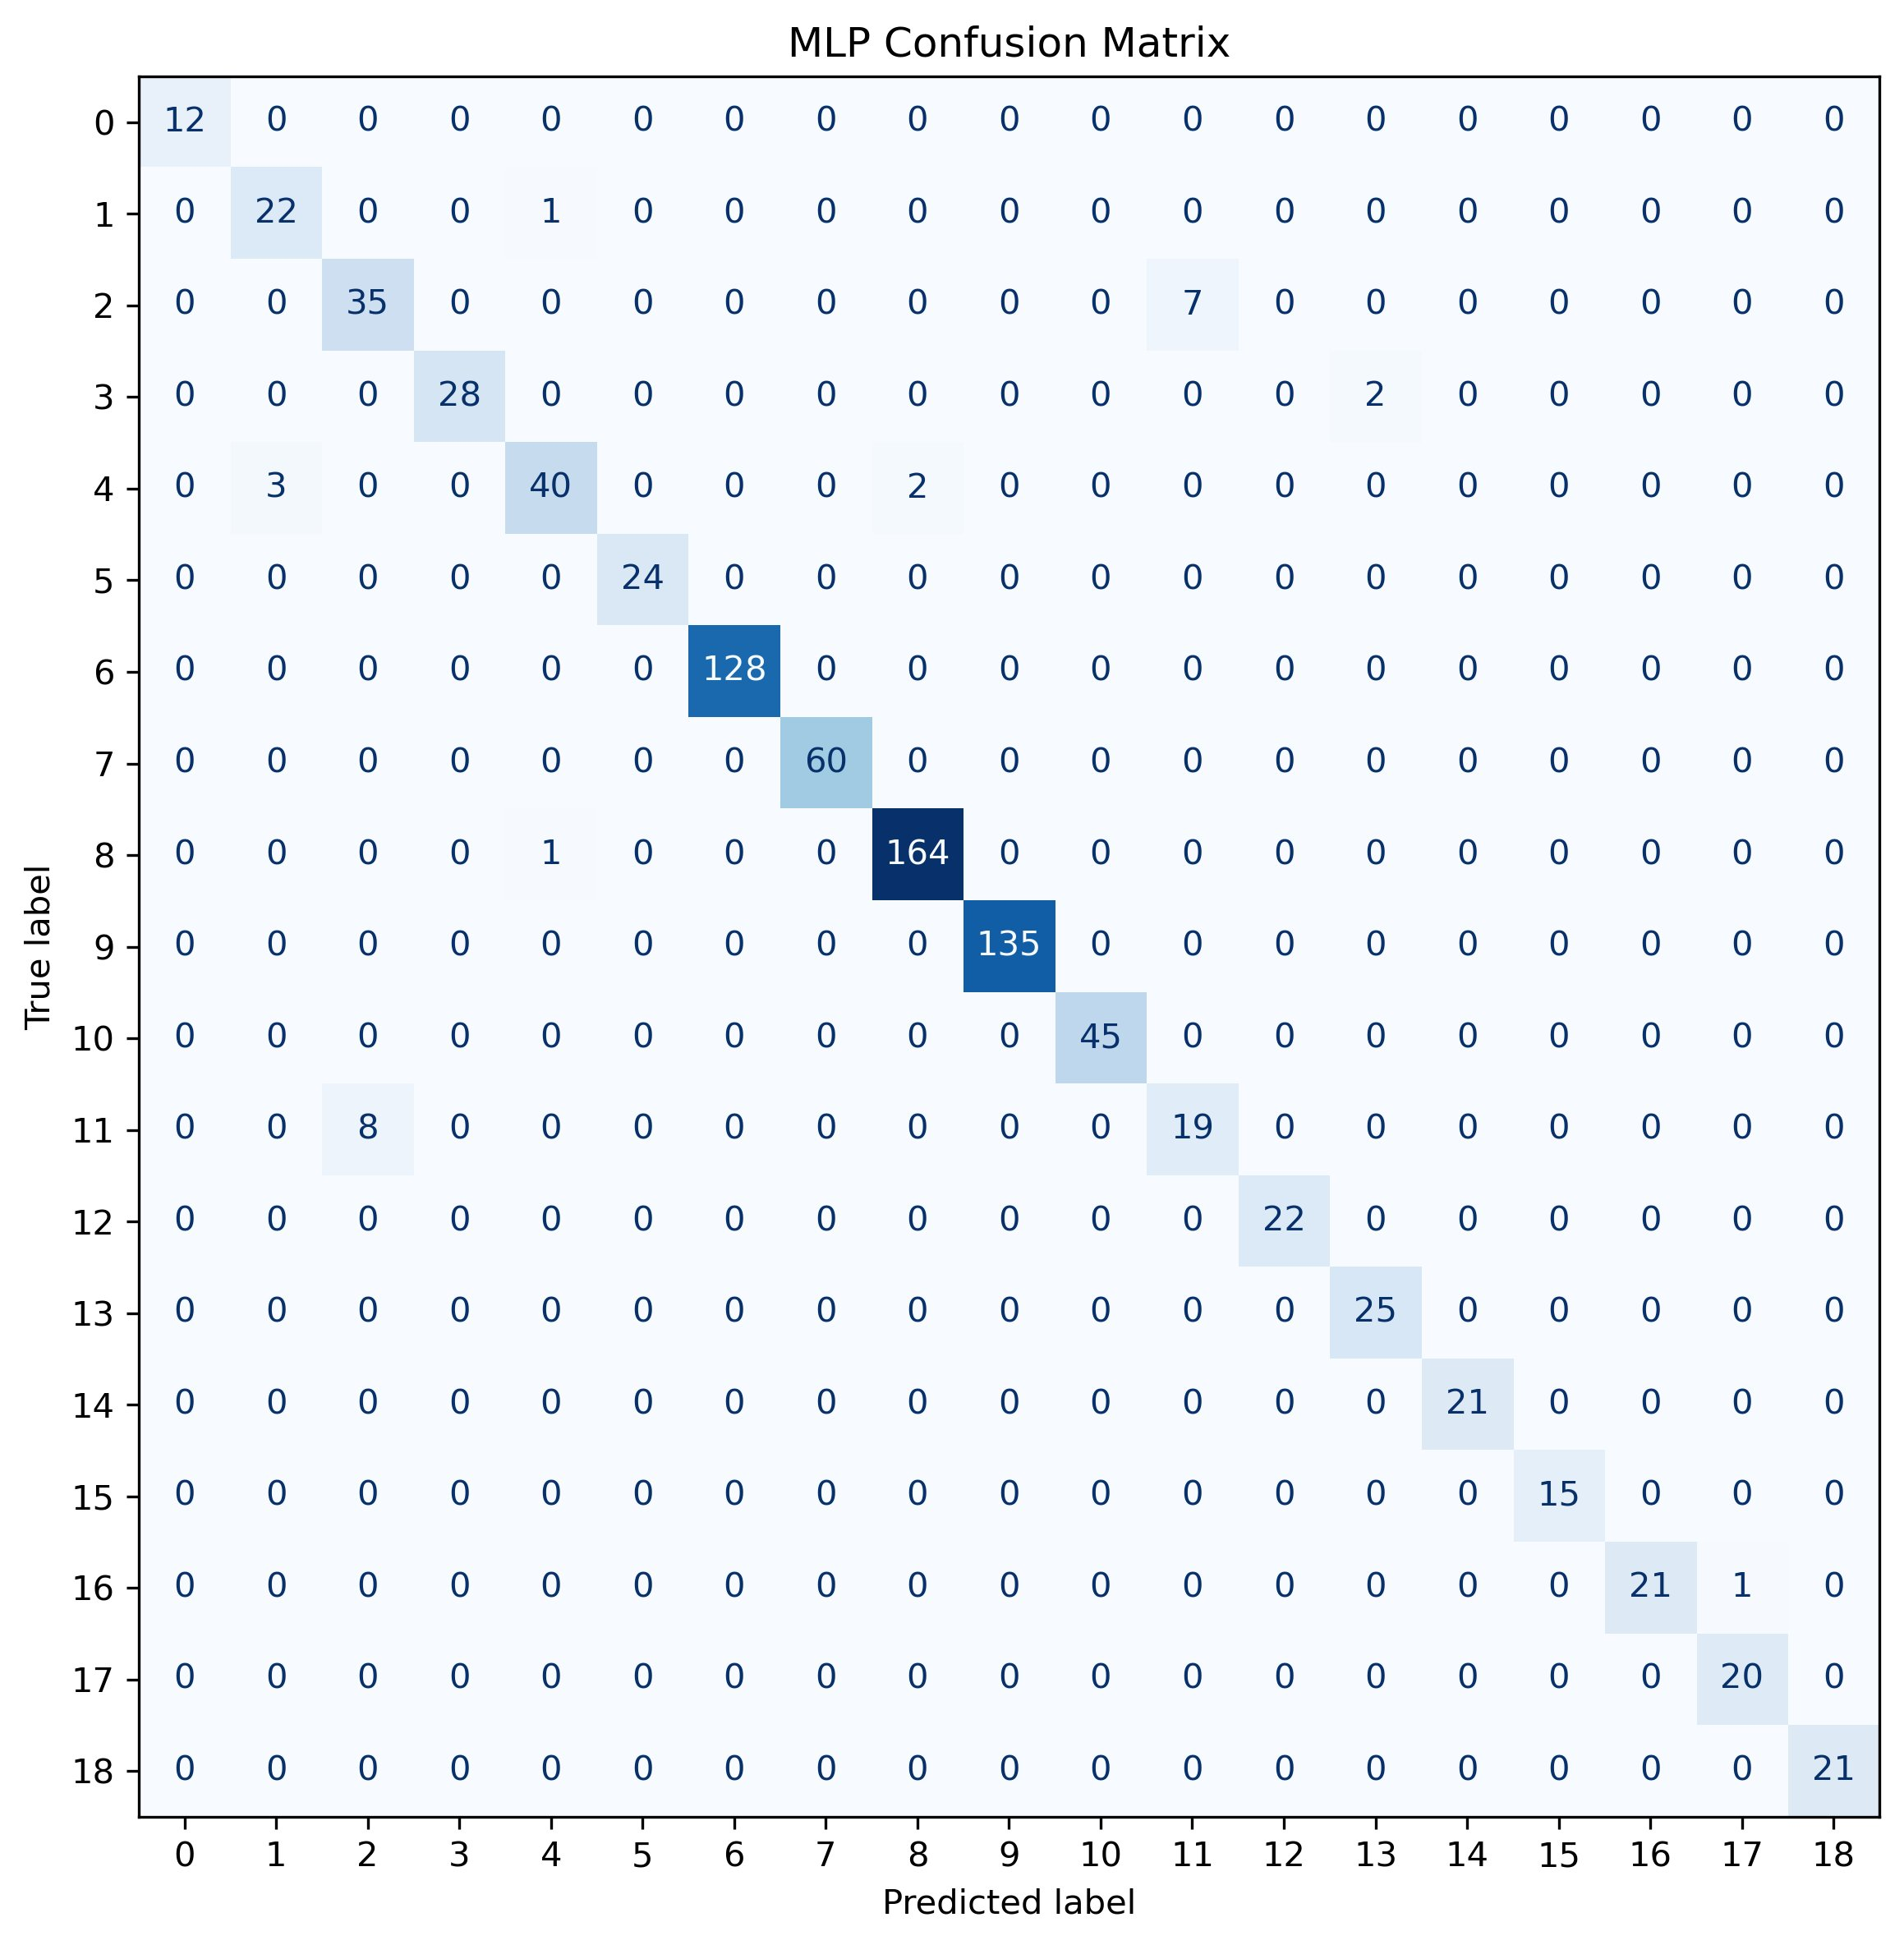

Fig. 3. Confusion matrix for the MLP. Performance is comparable to Logistic Regression, with some additional misclassifications in classes 3 and 11. The MLP shows slightly more scatter across off-diagonal cells, indicating its added complexity does not yield cleaner separation on this dataset.
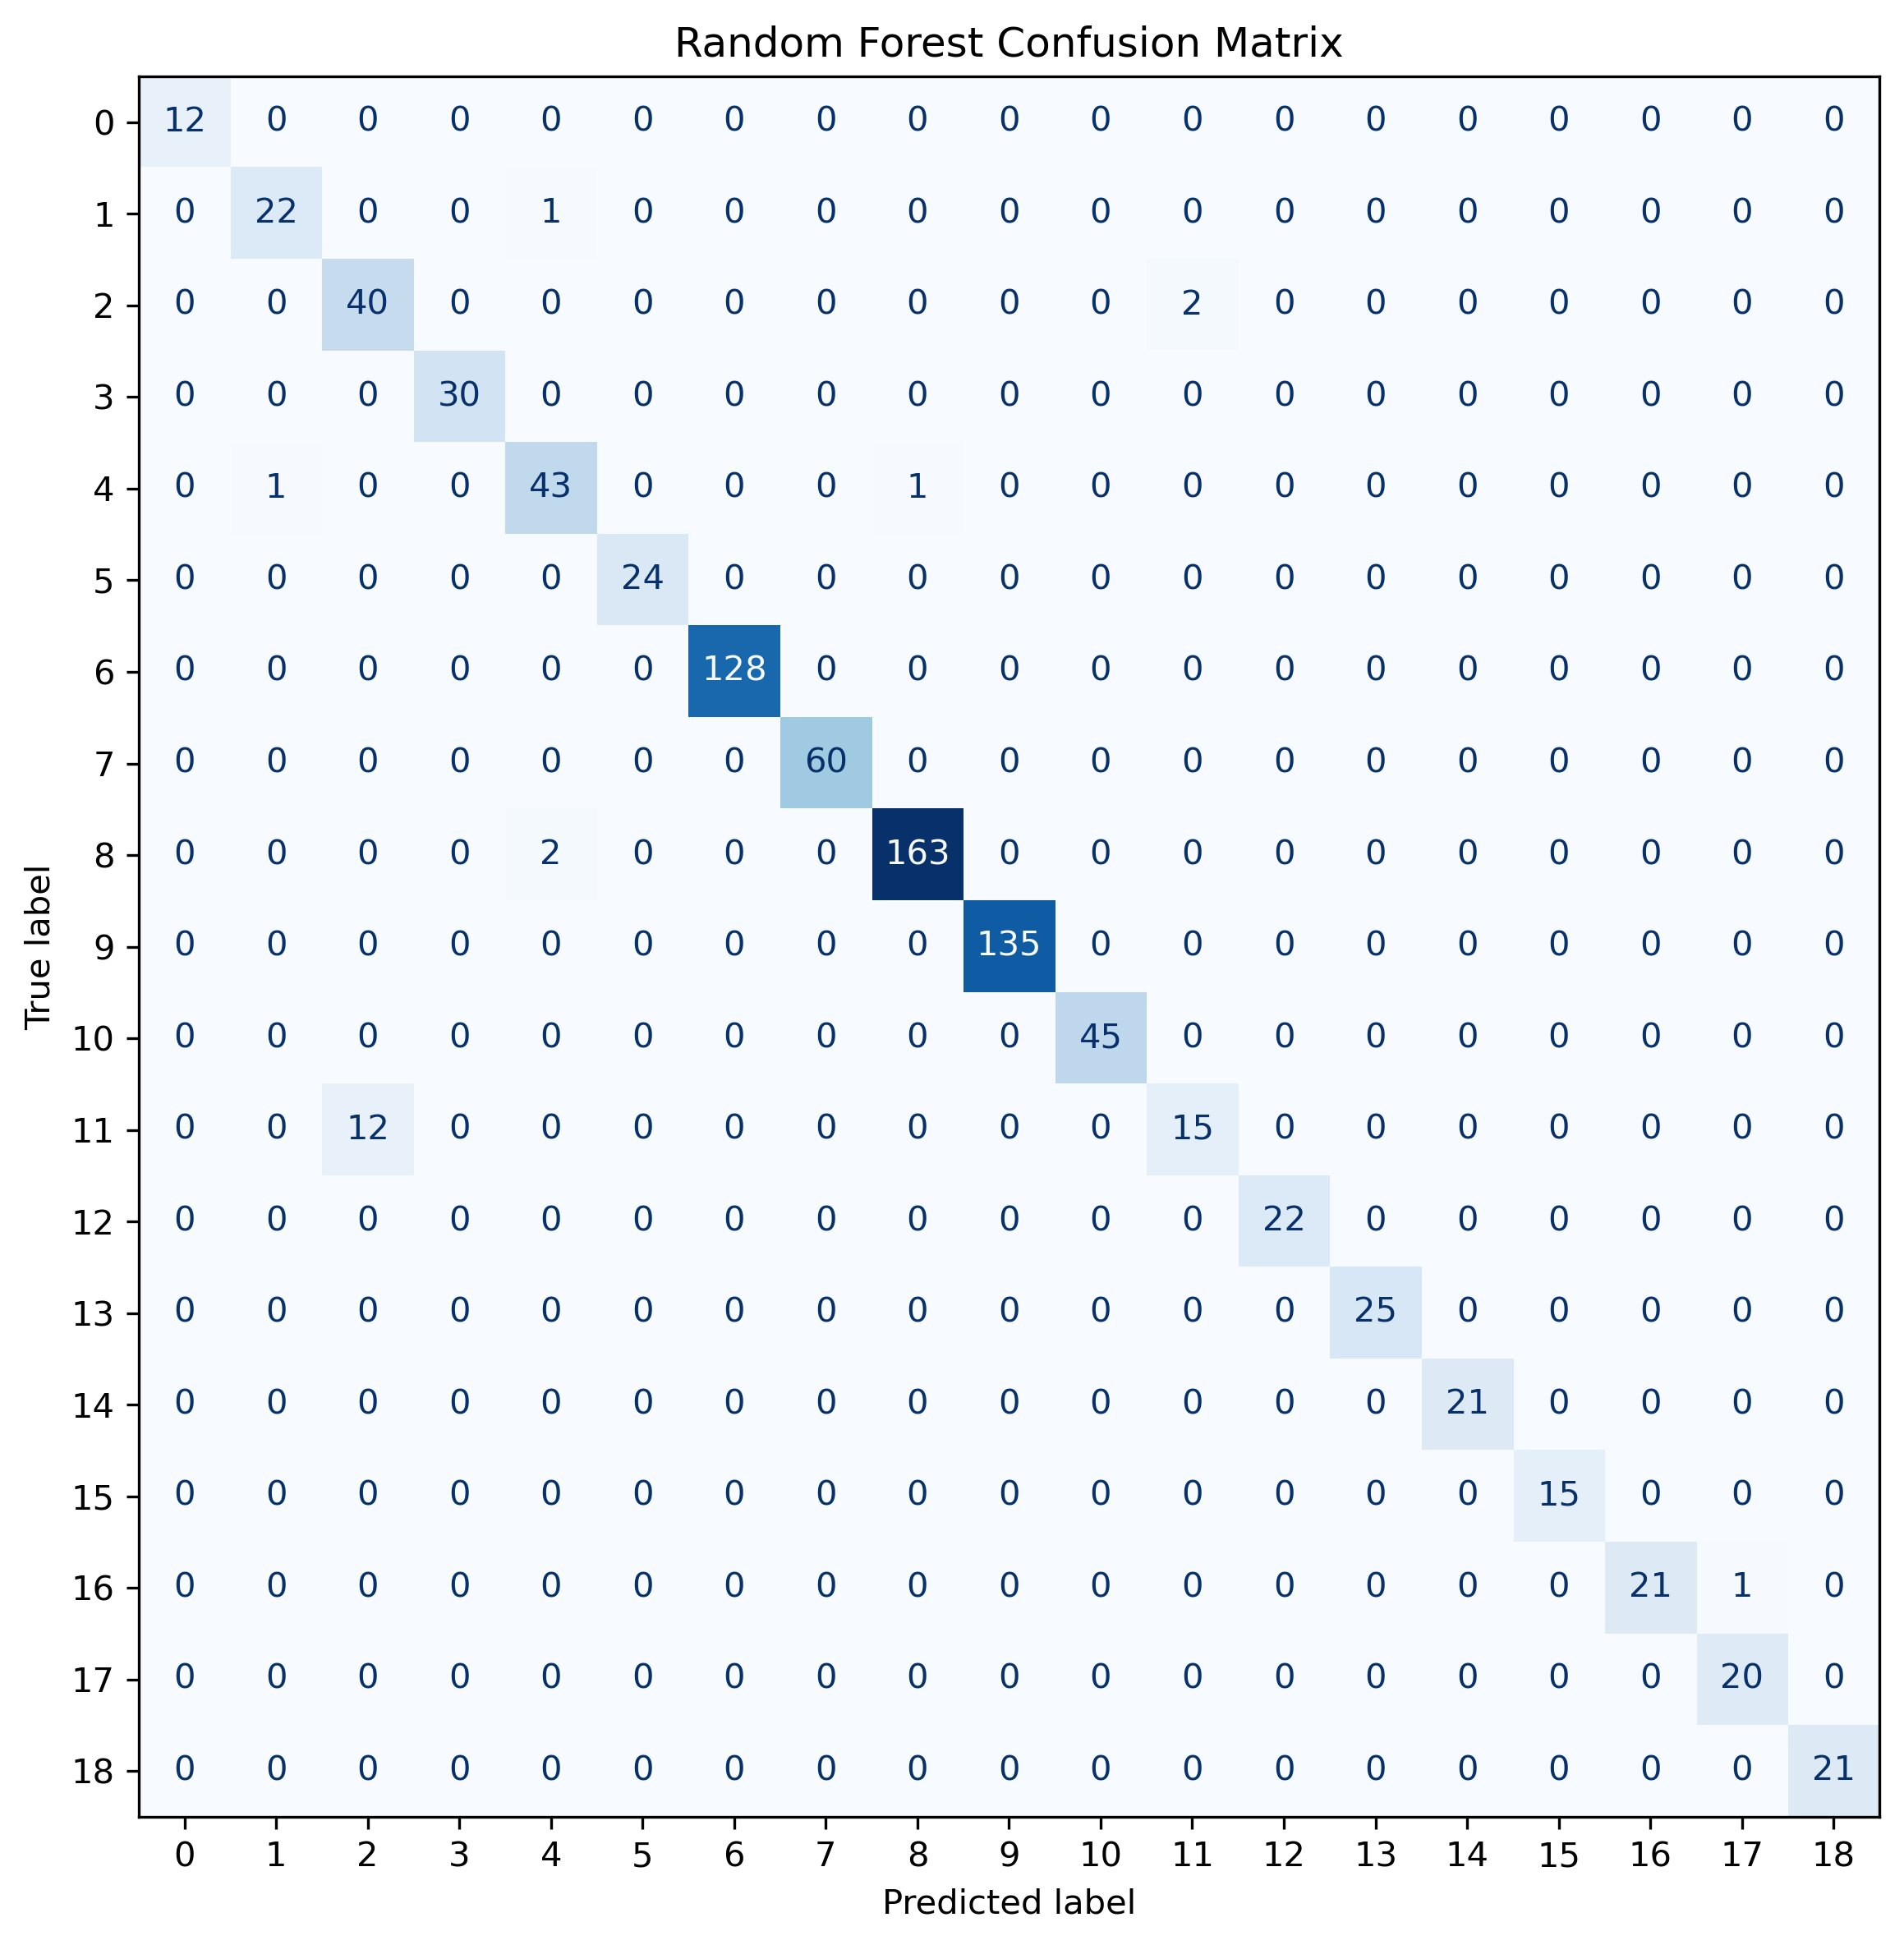

Fig. 4. Confusion matrix for Random Forest. This model achieves the fewest misclassifications overall. Class 11 still shows some confusion with class 2 (12 samples), but class 2 itself is classified more accurately (40/42) compared to the other models, reflecting the benefit of ensemble-based nonlinear decision boundaries.

Discussion
The experimental results provide several important insights into the underlying structure found within the dataset and the inherent behavior that separate machine learning models possess. All three models were able to achieve high classification performance, with all accuracies being able to exceed 96%. This indicates that the dataset is highly structured and contains strong predictive significance.
The strong performance found in Logistic Regression was particularly notable. As a linear model, it assumes that each class can be separated with a series of linear decision boundaries. Achieving an accuracy of 97.51% suggests that the majority of the dataset is inherently linear and can be linearly separated because of so. This then implies that the extracted features effectively capture characteristics of blood cell types, making the task of classification relatively straightforward in the lens from a modeling perspective. The other two Logistic Regression models also tell us another story, they show that we managed to reach a good elbow spot of our regularization value. Model 2 had a value of 2.0, Model 3 had a value of 0.5 and Model 1 had a value of 1.0. Regularization controls how large weights can become, which depending on the value might underfit, overfit, or find the ideal weights. Since Model 1 performed the best, we were able to find a good elbow point that was not underfitting (Model 3) nor overfitting (Model 2).
The Random Forest model achieved the highest accuracy at 97.73%, demonstrating it had a slight improvement over the linear baseline. This improvement indicates the presence of some nonlinear relationships in the dataset that was not able to be fully captured by Logistic Regression. Random Forest’s ensemble structure allows the model to pick up feature interactions and complex decision boundaries, which likely contributed to the marginally superior performance. However, the small difference in accuracy suggests that the nonlinear relationships found in the dataset are limited in scope. The other two Random Forest models also helped show the significance of max depth of trees. Model 1 had a max depth of 10, Model 2 had none, and Model 3 had a max depth of 20. Model 3 had the best performance which shows that the lower depth took away more complex patterns found in the deeper layers and the model without depth showed that it most likely overfit and became far too deep. There is likely more to be explored if the depth of the tree became larger, but clearly there is a limit since no limit showed lower performing results then a depth of 20.
Interestingly, the Multi-Layer Perceptron (MLP), even though it has the ability to model highly complex nonlinear relationships, did not outperform the other two simpler models. It had an accuracy of 96.94% and performed slightly worse than both Logistic Regression and Random Forest. This result highlights a critical concept in machine learning, and that is that an increased model complexity does not also guarantee an increased performance of said model. The underlying data and it’s complexity is what determines what type of model is needed, complexity in it of itself is a tool meant to be used, not a hyperparameter meant to be maxed out. Complexity may not provide increased benefits and might even worsen performance. Looking into the nature of dropout in this MLP, we had three models. Model 1 had a dropout of 0.1, Model 2 had none, and Model 3 had a dropout of 0.3. Model 3 performed the best, showing that the models with less (or none) dropout were likely overfitting. There is a case that perhaps more dropout might increase the performance of the model and more research might show that an increase in dropout was the only thing holding back the MLP from showing that the dataset might actually favor a more complex model.
From a practical perspective, the results suggest that simpler models such as Logistic Regression may be preferable for deployment due to their efficiency, interpretability, and ease of implementation. Random Forest although having slightly better performance, might not be justified in deployment due to the additional computational complexity in all applications. The neural network although powerful and able to capture complex relationships, does not offer a clear advantage in this scenario, not meriting the usage of its high cost nature.
Overall, the findings emphasize the important of understanding dataset characteristics when dealing with the task of selecting machine learning models. Rather than defaulting towards complex models, this study suggests that starting with simpler models and scaling up to more complex models until reaching an elbow point where the complexity does not merit the results is the ideal approach to follow in all application of machine learning.

Conclusion
This study illustrates a comparison between three types of machine learning approaches which were Logistic Regression, Random Forest, and Multi-Layer Perceptron. These models were used for the task of classification of blood cell anomalies using structured tabular data. The objective of this study was to evaluate how complexity influences the performance of a model and to determine which approach to use given the dataset. It also delved into the nature of certain hyperparameters being Dropout for Multi-Layer Perceptron, Regularization for Logistic Regression, and Max Depth for Random Forest.
The results demonstrated that all the models were able to reach a high classification accuracy, with Logistic Regression reaching 97.51%, Random Forest achieving 97.73%, and MLP achieving 96.94%. These findings indicate the dataset is highly separable and contain strong feature signals that even simple models can pick up.
One of the key conclusions of this study is that linear models can perform exceptionally well when the feature space is well structured. The strong performance for Logistic Regression highlights the effectiveness of the preprocessing pipeline, particularly feature encoding and scaling into a form that can be easily separable.
These results also highlight an important implication for real-world applications. Computational efficiency is very important when scaling large scale applications, so simpler models that require significantly less computation and power are perferred. Understanding the dataset and knowing at what point of complexity to reach is key. Although Random Forest performed better than Logistic Regression, it might still be preferred to use Logistic Regression due to its complexity and sacrificing the small difference in performance it likely worth it.
In conclusion, this study demonstrates that careful preprocessing and appropriate model selection are more important than model complexity alone. Selecting the right model for the data can lead to efficient and highly accurate solutions without the need of equally high complexity.

Acknowledgment
The authors would like to thank Ali Taqi Shah for making the Blood Cell Anomaly Detection 2025 dataset publicly available on Kaggle.

References
- A. T. Shah, "Blood Cell Anomaly Detection 2025," Kaggle, 2025. [Online]. Available: https://www.kaggle.com/datasets/alitaqishah/blood-cell-anomaly-detection-2025

